1) The generatrices of a conoidal surface are parallel FALSE

2) The generatrices of a conoidal surface are concurrent FALSE

2) The generatrices of a conical surface are concurrent TRUE

2) The generatrices of a conical surface are parallel FALSE

) The generatrices of a cylindrical surface intersect a certain fixed line and are parallel to a fixed plane FALSE

) The generatrices of a conical surface intersect a certain fixed line and are parallel to a fixed plane FALSE

) The generatrices of a conoidal surface intersect a certain fixed line and are parallel to a fixed plane TRUE

) The generatrices of a cylindrical are parallel TRUE

) The product (concatenation) of two affine transformations is an affine transformation. TRUE

) The inverse of an orthogonal reflection is itself. TRUE

) The inverse of a translation is a translation. TRUE

) The inverse of a rotation is a rotation. TRUE

) The inverse of a scaling about the origin is a scaling about the origin. TRUE

) The determinant of the homogeneous matrix of a shear can be negative FALSE

) A hyperbolic paraboloid is a generated surface TRUE

) A hyperbolic paraboloid is symmetrical with respect to the coordinate planes FALSE

) A hyperboloid of one sheet is a bounded surface FALSE

) A hyperboloid of one sheet is a generated surface TRUE

) A hyperboloid of one sheet is symmetrical with respect to the coordinate planes TRUE

) A projective transformaton L is invertibleif and only if its homogeneous transformation matrix is invertible TRUE

) An elliptic paraboloid is a bounded surface FALSE

) An ellipsoid is symmetrical with respect to the coordinate planes TRUE

) An affine transformation is singular if and only if it is invertible FALSE

)For any l and point A (not)∈l in the plane, the locus of points M in the plane so that MA = dist(M,l) is a parabola TRUE

)For any l and point A (not)∈l in the plane, the locus of points M in the plane so that MA = dist(M,l) is an ellipse FALSE

)For any l and point A (not)∈l in the plane, the locus of points M in the plane so that MA = dist(M,l) is an hyperbola FALSE

)For any two points A and B in the plane, the locus of points M in the plane so that |MA-MB| is a constant k > 0 is a parabola FALSE

)For any two points A and B in the plane, the locus of points M in the plane so that |MA-MB| is a constant k > 0 is a hyperbola TRUE

)For any two points A and B in the plane, the locus of points M in the plane so that MA+MB is a constant k > 0 is a hyperbola FALSE

) Every affine transformation is linear FALSE

) Every linear transformation is affine TRUE

) Every rotation around the origin is a linear transformation TRUE

) Every reflection with respect to a line through the origin is a linear transformation. TRUE

) Every reflection with respect to a line is a linear transformation. FALSE

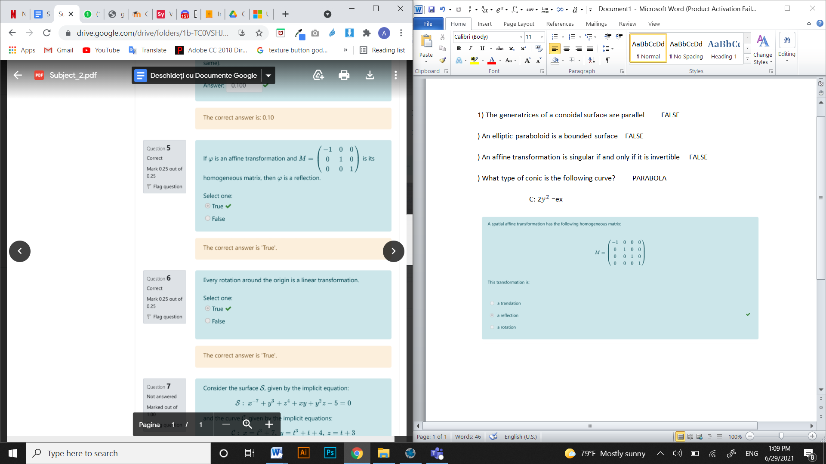

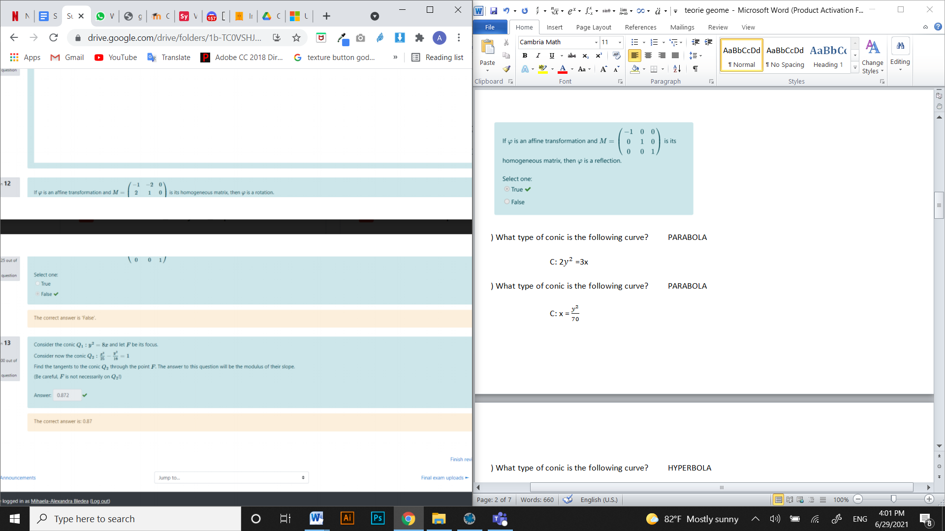

) What type of conic is the following curve? PARABOLA

C: 2 $y^{2}$ =3x

) What type of conic is the following curve? PARABOLA

C: x = $\frac{y^{2}}{70}$

) What type of conic is the following curve? HYPERBOLA

C: $\frac{x^{2}}{-4}$ + $\frac{y^{2}}{9}$ = 3

) What type of conic is the following curve? HYPERBOLA

C: $\frac{x^{2}}{4}$- $\frac{y^{2}}{9}$ = 2

) What type of quadric is the following surface? ELLIPTIC PARABOLOID

S: $y^{2}$ + $\frac{z^{2}}{2}$- 8x=0

) What type of quadric is the following surface? ELLIPSOID

S: $-\frac{x^{2}}{-3}-\frac{y^{2}}{5}$ + $\frac{z^{2}}{-8}$ = -3

) What type of quadric is the following surface? HYPERBOLOID OF ONE SHEET

S: $\frac{x^{2}}{3}-\frac{y^{2}}{8}$ + $\frac{z^{2}}{5}$ = 2

) What type of quadric is the following surface? ELLIPSOID

S: $x^{2}+\frac{y^{2}}{9}$ + $\frac{z^{2}}{5}$-4

) What type of quadric is the following surface? ELLIPTIC PARABOLOID

S: $\frac{x^{2}}{9}$ + $\frac{z^{2}}{2}$ = 3y

) This type of conic has oblique asymptotes. What is it? PARABOLA

) This type of conic is bounded. What is it? ELLIPSE

) This type of conic does not have a center of symmetry. What is it? HYPERBOLA

) The intersections between this type of quadric and the coordinate planes are all ellipses. It is:

AN ELLIPSOID

) The intersections between this type of quadric and the coordinate planes are: two hyperbolas and one ellipse. It is:

A HYPERBOLOID OF ONE SHEET

) The intersections between this type of quadric and the coordinate planes are: two hyperbolas and an empty set. It is:

A HYPERBOLOID OF TWO SHEETS

